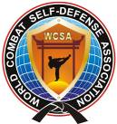


Invitation for
THE SIXTH MARTIAL ARTS
OLYMPICS «EAST-WEST OPEN»

WWW.IMAC-OLIMP.COM / WWW.IMAC93@LIST.RU

INTERCONTINENTAL TOURNAMENT

OPEN EUROPE CUP OF «COMBAT SELF-DEFENSE»
men, women, juniors, cadets
SHADOW-FIGHTS, SELF-DEFENSE, ATTACK-TESTS, SAFE-POINT,
ММА: SAFE-COMBAT, LIGHT-COMBAT, FREE- COMBAT, MIX-COMBAT

WWW.COMBATSD.COM

ST.-PETERSBURG, 26-29 APRIL 2012
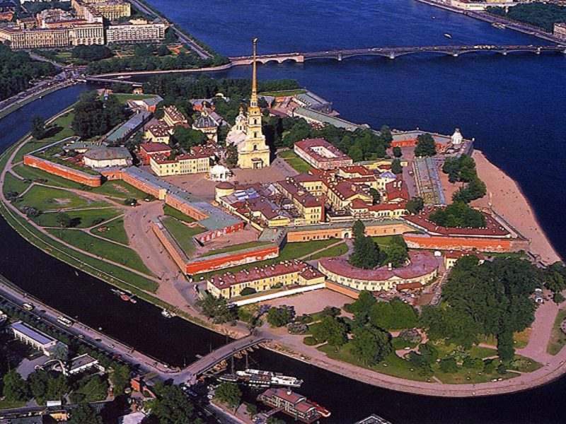 | 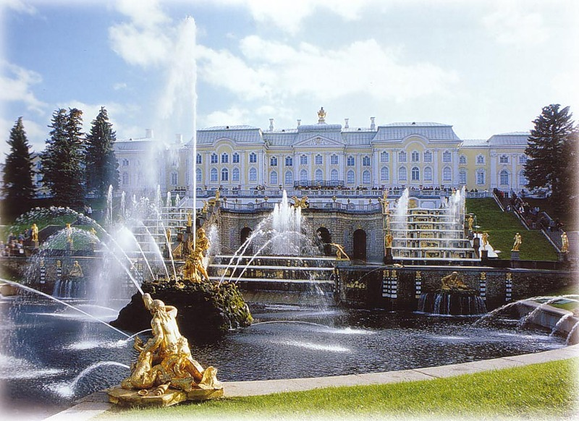 | 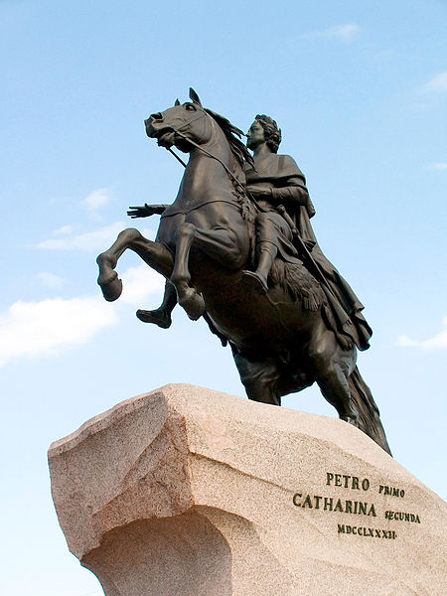 | 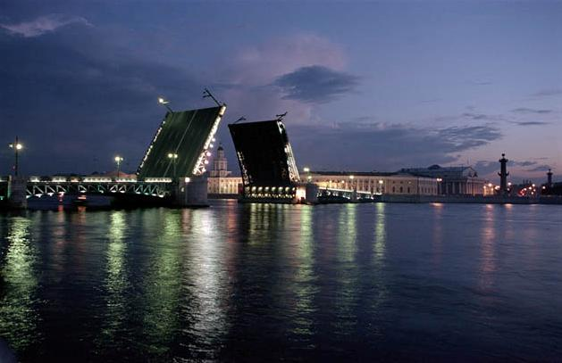

1) DATE: 25th April– 29th April 2012. Arrival date of the foreign Olympics participants – April 24th-26th, departure – April 30th.

2) PLACE: St.Petersburg“ - Pulkovo” International Airport

3) PROMOTER: Aleksandr Sosnin (Chairman and Technical Director of WCSA, 6-th Dan/Degree)

4) ORGANIZERS: World Combat Self-defense Association, International Martial Arts Confederation

5) WEIGHT & PASSPORT CONTROL: 26th April 2012 (Sport Concert Complex “Peterburgskiy” (Yuri Gagarin Avenue 8, Travel subway station “Park Pobedy”).

6) JUDGES AND REFEREES: Those who are interested in participation as judges and referees should inform, that they are going to attend a seminar. All Delegations are obligated to bring at least one (1) Judge or referee otherwise they will face a penalty. The seminar for judges will take place on April, 26th to destination.

7) CONDITIONS FOR PARTICIPATION: Start of the fights: 27th April from 09.00 a.m. at Sport Concert Complex “Peterburgskiy”. Allowed to start: Fighters of any styles and organizations, with a medical attestation. Each command should have at itself a national Hymn (on CD-disk) and the Flag.
Starting fees:
- €25 per participant, per division by March 26th, 2012.
Late Registration:
- €35 per participant, per division.
- athletic passport – 10 €. The fighter can participate in different disciplines.
In the absence of equipment will stand out in rent

8) ACCOMMODATION: Price Hotel from 40 euro 1 day for person.

Information: e-mail: wcombatsd@gmail.com; combatsd@mail.ru

9) DIVISIONS:

Shadow-fights
Attack-tests to12 years; 12-15 years; 16+ years
Self-defense

Winners and prize-winners of disciplines are awarded by a medal and the diploma, if in it not less than 4 participants.
9.1.1. Discipline – «Shadow Fights» . Free demonstration of techniques of hands, feet and slopes (time of execution -- 30-60 seconds).
9.1.2. The discipline - "Self-defense" (the executor + the assistant () – is estimated only the executor. Time of execution from 1,5 till 3 minutes
9.1.3. Discipline – «Attack-Tests» . Testing with the assistant (trainer) on paws, with blows by hands (1st round), feet (2nd round) in a combination to possible slopes and the waste techniques with the partner of a corresponding weight category (3rd round). Execution time 3 rounds for 20 seconds.
In the given section the sportsman and his instructor are estimated. (2 medals).

«Safe-Point»:

Equipment: a jacket and trousers (kimono), a helmet (type "safe"), protection of a shin and foot lifting, a groin protector. For girls the presence of a protector on a breast is necessary.
Fight lasts 90 seconds of pure time or to advantage in five points (gloves ММА or for hand-to-hand fight - And, In, About a class). Class D, Е - 60 seconds, gloves (4 + and 6 + ounces accordingly).

Class Years Weight, kg
Men | 18-40 | -60 | -68 | -77 | -86 | 86+
Women | 18-35 | -50 | -57 | 57+
Junior A-class (male) | 16-17 | -55 | -63 | -71 | -80 | 80+
Junior A-class (female) | 16-17 | -45 | -50 | -57 | 57+
Junior B-class (male) | 14-15 | -48 | -55 | -63 | -71 | 71+
Junior B-class (female) | 14-15 | -40 | -45 | -51 | 51+
Junior C-class (male) | 12-13 | -36 | -40 | -45 | -51 | 51+
Junior C-class (female) | 12-13 | -35 | -42 | 42+
Junior D-class (male) | 10-11 | -30 | -34 | -39 | -45 | 45+
Junior D-class (female) | 10-11 | -30 | -35 | -40 | 40+
Junior E-class (male) | 7-9 | -23 | -26 | -30 | -35 | 35+
Junior E-class (female) | 7-9 | -23 | -26 | -30 | 30+

Categories are considered full in the presence of 4 participants, otherwise
The credentials committee has the right to unite the next categories
(The difference in weight can't make more than 20 %)

M M A:

«Safe-Сombat»:

Equipment: a dense kimono, a helmet (type "safe"), gloves (for ММА or hand-to-hand fight), a groin protector. Fight lasts for adults 2 rounds for 2 minutes, A,B,C classes - 2 rounds for 1,5 minutes. Class D - 2 rounds for 1 minute, at class Е-2 of a round for 45 seconds.
Break between rounds for 30 seconds.
Any shock correct techniques in a rack, in a ground position attack by hands and feet at the torso, in a head only fixed blows by hands is resolved. Painful and suffocating receptions are resolved (on attempt 10 seconds) are given.

Class Years Weight, kg
Men | 18-35 | -56 | -60 | -65 | -71 | -78 |  | -86  -95 | +95
Woman | 18-35 | -50 | -55 | -60 | -65 | -70 | +70
Junior A-class (male) | 16-17 | -53 | -56 | -60 | - | 65  -71 | -78 | -86 | +86
Junior A-class (female) | 16-17 | -45 | -50 | -55 | -60 | +60
Junior B-class (male) | 14-15 | -45 | -50 | -55 | -60 | -65 | -70 | +70
Junior B-class (female) | 14-15 | -40 | -45 | -50 | -55 | +55
Junior C-class (male) | 12-13 | -35 | -40 | -45 | -50 | -55 | -60 | +60
Junior C-class (female) | 12-13 | -35 | -40 | -45 | +45
Junior D-class (male) | 10-11 | -30 | -34 | -39 | -45 | 45+
Junior D-class (female) | 10-11 | -30 | -34 | -39 | 39+
Junior E-class (male) | 7-9 | -23 | -26 | -30 | -35 | 35+
Junior E-class (female) | 7-9 | -23 | -26 | -30 | 30+
In all classes is used of a soft protector on a breast, at will, is supposed (Under a kimono).
For girls obligatory is used a protector in all age categories.
In classes E and D - obligatory use of a protector on a breast, and boxing gloves (4-6, 8-10 ounces accordingly).
In class D – the shock techniques in a ground position (the formula of fight 2 rounds for 1 minute) is forbidden
In class Е – ground position is prohibited (the formula of fight 2 rounds for 45 seconds).

«Light-Combat»

Equipment: a naked torso, shorts, a helmet (open type), gloves of open type (not less than 10 ounces, boxing gloves are supposed), protection of a shin and foot lifting, a groin protector, protection of teeth. For girls necessarily presence of a protector on a breast. Fight lasts 2 rounds for 2 minutes. Any is resolved shock and throw the correct techniques in a rack. In a head are resolved only supervised, dosed out, not the strong blows (Light). In a ground position only wrestling (10 seconds) against painful and suffocating receptions. The shock techniques in a ground position are forbidden!

Class Years Weight, kg
Junior B-class (male) | 14-15 | -45 | -50 | -55 | -60 | -65 | -70 | +70
Junior B-class (female) | 14-15 | -40 | -45 | -50 | -55 | +55
Junior C-clas | (male)  12-13 | -35 | -40 | -45 | -50 | -55 | -60 | +60
Junior C-class (female) | 12-13 | -35 | -40 | -45 | +45

«Free - Combat»

Equipment: a naked torso, shorts for the mixed single combats, an open helmet, protection of teeth, gloves opened with a soft filler (for hand-to-hand fight), the groin protector , a shin and foot lifting.
Fight lasts two rounds for 2 minutes, with a break for 30 seconds - adults, and a 2*1,5-A class (are possible 3 rounds of fight in the finals). Any is resolved shock and throw the correct techniques in a rack, in a ground position - painful and suffocating, having the instant continuation from a rack (to 10 seconds), blows in a ground position are forbidden.

Class Years Weight, kg
Men | 18-20 | -56 | -60 | -65 | -71 | -78 | -86 | -95 | 95+
Woman | 18-35 | -50 | -55 | -60 | -65 | -70 | +70
Junior A-class (male) | 16-17 | -53 | -56 | -60 | -65 | -71 | -78 | -86 | 86+
Junior A-class (female) | 16-17 | -45 | -50 | -55 | -60 | +60

«Mix-Combat»
Equipment: a naked torso, shorts for the mixed single combats, an open helmet, protection of teeth, gloves (ММА), the groin protector , a shin and foot lifting. Any shock correct techniques in a rack, throws, painful and suffocating receptions is resolved. Blows by hands and feet in a ground position at the torso, the limited quantity of blows by hands in a head (to 3 blows successively). The fight formula: 2 rounds for 3 minutes, the endings rounds for 3 minutes.
Class Years Weight, kg
Men | 18-35 | -56 | -60 | -65 | -71 | -78 | -86 | -95 | 95+

Prize Money
for Winners!

10) PROGRAM OF THE EVENT:

24 - 26 April — day of arrival, weighing, credentials committee, the drawing of lots, practice, rehearsal and run for participants of budo-show;
26 April - International Conference of WCSA;
27 - 29 April — the competition of all martial arts styles, kinds, age and weight categories.
27 April at 19.00 — Official Opening Ceremony of the Olympics, parade and budo-show.
28 April at 20:00 are going to be held title fights for the St. Petersburg governor Cup on the base of a free-style fights (MMA). In fights are participating national champions of Azerbaijan, India, Iran, Russia and other countries.
April 30 — the day of departure.
11) CONTACT: +7 9177619080 Aleksandr Sosnin

12) CONTACT – VISA DOCUMENTS:

Moscow time (GMT +3), call:
• +7 (812) 327 3866
• +7 (812) 327 3056
• Fax: +7 (812) 327 3867
For more Information or Visa Documents please contact:

• accommodation and visa support: tani@inturion.ru - Tatiana Vdovkina
CEO: inna@inturion.ru — Inna Ponomareva
Details — are located at the company website www.inturion.ru and website of IMAC www.imac-olymp.ru or www.imac-olymp.com
Attention to foreign citizens!
Applications for visa invitations must be submitted no later than March 15, 2012
• The citizens of Afghanistan, Algeria, Bangladesh, Bosnia, Vietnam, Egypt, Ghana, India, Jordan, Iran, Libya, Nigeria, United Arab Emirates, Pakistan, Palestine, Rwanda, Saudi Arabia, North Korea, Syria, Somalia, Sudan, Turkey, Chad, Sri Lanka, Ethiopia, must submit their applications until March 1, 2012 due to specific operating schedule of the Russian consulates in these countries.
Any questions regarding your participation in the upcoming Olympics, you can send to the Board at the Olympics via e-mail: imac93@list.ru
Arrival & Departure Details
Country:……………………………………………………………………………………………………..
National Federation/Association's Name:………………………………………………………………………………………………….
Name of Representative:…………………….…………………………………….………………………..
Address:………………………………………………………………………………………………………………………………………………………
E-mail:…………………………………………………………………………………………………………
Telephone / Fax:…………………………………………………………………………..…………………
Flight Schedule:
Date of Arrival: …………………………… ………. Time of Arrival:…………………. …………………. No. of Persons:…………………………………… Flight No:…………………………………………… Airline Name:……………………………… …..…………………………………………………………….
Date of Departure: …………………………… ……Time of Departure:………………………………… No. of Persons:…………………………………… Flight No:…………………………………………… Airline Name:……………………………… …..…………………………………………………………….

